**How can we add page labels while importing pages from one PDF to another using Syncfusion Essential PDF in a C#**

The Syncfusion Essential® PDF is a feature-rich and high performance [**.NET PDF library**](https://www.syncfusion.com/document-processing/pdf-framework/net) used to create, read, and edit PDF documents programmatically without Adobe dependencies. Using this library, you can add page labels while importing pages from one PDF to another using C#.

**Steps to add page labels while importing pages from one PDF to another programmatically:**

1. Create a new console application project.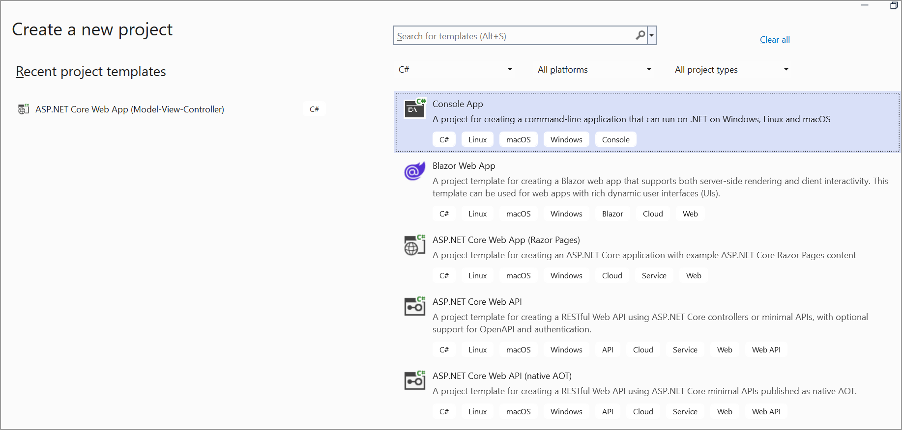
2. Install the [**Syncfusion.Pdf.Net.Core**](https://www.nuget.org/packages/Syncfusion.Pdf.Net.Core) NuGet package as a reference to your console application from [**Nuget.org**](https://www.nuget.org/).

1. Include the following necessary namespaces in your Program.cs file.

**C#**

using **Syncfusion**.Pdf.Graphics;

using **Syncfusion**.Pdf.Parsing;

using **Syncfusion**.Pdf;

using **Syncfusion**.Drawing;

1. Add the following code to your Program.cs to import pages from one PDF to another and add page labels:  
   **C#**

// Open the first PDF document (Barcode.pdf).

**FileStream** inputFileStream = **new** **FileStream**(@"../../../Barcode.pdf", **FileMode**.Open, **FileAccess**.Read, **FileShare**.ReadWrite);

// Load the PDF document.

**PdfLoadedDocument** loadedDocument = **new** **PdfLoadedDocument**(inputFileStream);

// Create a new PDF document.

**PdfDocument** document = **new** **PdfDocument**();

// Add a section to the new document.

**PdfSection** section = document.Sections.**Add**();

// Set page label style and starting number for the section.

section.PageLabel = **new** **PdfPageLabel**();

section.PageLabel.StartNumber = 1;

section.PageLabel.NumberStyle = **PdfNumberStyle**.UpperRoman;

// Set page margins to zero.

section.PageSettings.Margins.All = 0;

// Iterate through pages of the loaded document.

**for** (int i = 0; i < loadedDocument.Pages.Count; i++)

{

// Add a new page to the section.

**PdfPage** page = section.Pages.**Add**();

// Create page as template from the loaded document.

**PdfTemplate** template = loadedDocument.Pages[i].**CreateTemplate**();

// Draw the template on the new page.

page.Graphics.**DrawPdfTemplate**(template, **PointF**.Empty, template.Size);

}

// Open the second PDF document (Invoice.pdf).

loadedDocument = **new** **PdfLoadedDocument**(**new** **FileStream**(@"../../../Invoice.pdf", **FileMode**.Open));

// Add another section to the new document.

**PdfSection** section1 = document.Sections.**Add**();

// Set page label style and starting number for the second section.

section1.PageLabel = **new** **PdfPageLabel**();

section1.PageLabel.StartNumber = 1;

section1.PageLabel.NumberStyle = **PdfNumberStyle**.Numeric;

// Set page margins to zero.

section1.PageSettings.Margins.All = 0;

// Iterate through pages of the second loaded document.

**for** (int i = 0; i < loadedDocument.Pages.Count; i++)

{

// Add a new page to the second section.

**PdfPage** page = section1.Pages.**Add**();

// Create page as template from the second loaded document.

**PdfTemplate** template = loadedDocument.Pages[i].**CreateTemplate**();

// Draw the template on the new page.

page.Graphics.**DrawPdfTemplate**(template, **PointF**.Empty, template.Size);

}

// Close the loaded document.

loadedDocument.**Close**(true);

// Create a memory stream to save the new document.

**MemoryStream** stream = **new** **MemoryStream**();

// Save the new document to the memory stream.

document.**Save**(stream);

// Close the new document.

document.**Close**(true);

// Write the new document from the memory stream to a file.

**File**.**WriteAllBytes**(@"Output.pdf", stream.**ToArray**());

A complete working sample can be downloaded from [**page_labels_while_importing_pages_from_one_PDF_to_another.zip**](https://www.syncfusion.com/downloads/support/directtrac/general/ze/Page_labels_while_importing_pages-1777491703.zip)

By following these steps and using the provided code, you will create a new PDF document that imports pages from two existing PDFs (Barcode.pdf and Invoice.pdf). Each section of the new document will have its own page labels with different numbering styles. The first section uses upper Roman numerals, and the second.A screenshot of a computer

Take a moment to peruse the documentation for [**working with pages**](https://help.syncfusion.com/document-processing/pdf/pdf-library/net/working-with-pages), where you will find other options like inserting, removing, and rearranging pages in PDF document, adding margin, and importing pages from the existing PDF document.

Refer [**here**](https://www.syncfusion.com/document-processing/pdf-framework/net)to explore the rich set of Syncfusion Essential® PDF features.